Title of the Article with Capital Letters on Main Words

Firstname Lastname¹ and Prénom Nom²
¹EPITA, ²Université de technologie de Troyes

This paper was presented at Botconf 2023, Strasbourg, 11-14 April 2023, www.botconf.eu
This paper is published in the Journal on Cybercrime & Digital Investigations by CECyF, https://journal.cecyf.fr
It is shared under the CC BY license http://creativecommons.org/licenses/by/4.0/.

Abstract
The abstract should be a brief summary of the significant items of the paper. It should be informative and not only present the general scope of the paper but also indicate the main results. It should contain 150-200 words.
Authors should remember that online systems rely on the title and abstract to identify articles in electronic bibliographic databases and search engines. They should therefore take great care in preparing these elements.
Keywords: botnet, IDS, network security.

Introduction
The introduction is supposed [1] to present the structure [2] of the paper.
This particular template is meant for English papers. To switch to French, one simply needs to update the options of the \texttt{babel} package to \texttt{french} instead of \texttt{english}.
The current structure of this sample paper is only a suggestion for the sections that are needed in a scientific paper:
- Introduction
- Description of the problem and possible solutions
- The implementation experimented and its evaluation
- Discussion on the results
- Related work
- Future work
- Conclusion

Feel free to choose a different structure, should you feel it is better adapted to your specific problem.
For legal papers, you will need to adapt to your specific situation and academic standards.

Problem and possible solutions
Hello, here is some text without a meaning. This text should show what a printed text will look like at this place. If you read this text, you will get no information. Really? Is there no information? Is there a difference between this text and some nonsense like “Huardest gefburn”? Kjift – not at all! A blind text like this gives you information about the selected font, how the letters are written and an impression of the look. This text should contain all letters of the alphabet and it should be written in of the original language. There is no need for special content, but the length of words should match the language.

Sub section on describing the problem
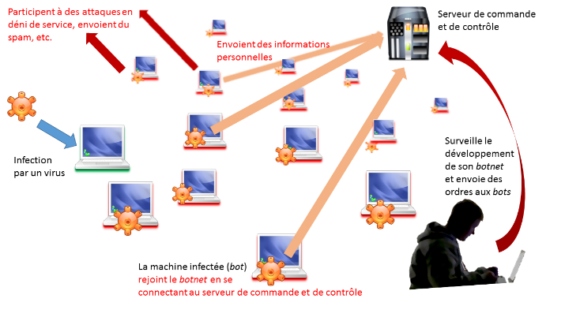
Hello, here is some text without a meaning. This text should show what a printed text will look like at this place. If you read this text, you will get no information. Really? Is there no information? Is there a difference between this text and some nonsense like “Huardest gefburn”? Kjift – not at all! A blind text like this gives you information about the selected font, how the letters are written and an impression of the look. This text should contain all letters of the alphabet and it should be written in of the original language. There is no need for special content, but the length of words should match the language.
Figure 1: Example of a full width picture

Figures and tables
Figures should be clear, easy to read and of good quality. All figures must be mentioned in the text in consecutive order and be numbered with Arabic numerals. To insert full width pictures in Word, simply insert an image and have the text go around it, such as with Figure 1.
If you want to insert a smaller picture, inside one of the columns, it is simply necessary to insert that figure in place, such as with Figure 2.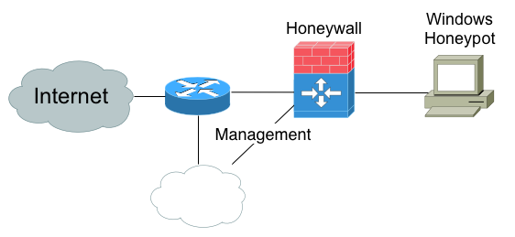
Figure 2: Example of a smaller figure directly inside a column
Moreover it is also possible to insert tables inside columns such as with
Colonne 1 | Colonne 2 | Colonne 3
1.1 | 1.2 | 1.3
2.1 | 2.2 | 2.3
Table 1: Example of small table inserted in a column

Implementation and evaluation
Hello, here is some text without a meaning. This text should show what a printed text will look like at this place. If you read this text, you will get no information. Really? Is there no information? Is there a difference between this text and some nonsense like “Huardest gefburn”? Kjift – not at all! A blind text like this gives you information about the selected font, how the letters are written and an impression of the look. This text should contain all letters of the alphabet and it should be written in of the original language. There is no need for special content, but the length of words should match the language.
Hello, here is some text without a meaning. This text should show what a printed text will look like at this place. If you read this text, you will get no information. Really? Is there no information? Is there a difference between this text and some nonsense like “Huardest gefburn”? Kjift – not at all! A blind text like this gives you information about the selected font, how the letters are written and an impression of the look. This text should contain all letters of the alphabet and it should be written in of the original language. There is no need for special content, but the length of words should match the language

Discussion
Hello, here is some text without a meaning. This text should show what a printed text will look like at this place. If you read this text, you will get no information. Really? Is there no information? Is there a difference between this text and some nonsense like “Huardest gefburn”? Kjift – not at all! A blind text like this gives you information about the selected font, how the letters are written and an impression of the look. This text should contain all letters of the alphabet and it should be written in of the original language. There is no need for special content, but the length of words should match the language.

Related work
Hello, here is some text without a meaning. This text should show what a printed text will look like at this place. If you read this text, you will get no information. Really? Is there no information? Is there a difference between this text and some nonsense like “Huardest gefburn”? Kjift – not at all! A blind text like this gives you information about the selected font, how the letters are written and an impression of the look. This text should contain all letters of the alphabet and it should be written in of the original language. There is no need for special content, but the length of words should match the language.

Future work
Hello, here is some text without a meaning. This text should show what a printed text will look like at this place. If you read this text, you will get no information. Really? Is there no information? Is there a difference between this text and some nonsense like “Huardest gefburn”? Kjift – not at all! A blind text like this gives you information about the selected font, how the letters are written and an impression of the look. This text should contain all letters of the alphabet and it should be written in of the original language. There is no need for special content, but the length of words should match the language.

Conclusion
Hello, here is some text without a meaning. This text should show what a printed text will look like at this place. If you read this text, you will get no information. Really? Is there no information? Is there a difference between this text and some nonsense like “Huardest gefburn”? Kjift – not at all! A blind text like this gives you information about the selected font, how the letters are written and an impression of the look. This text should contain all letters of the alphabet and it should be written in of the original language. There is no need for special content, but the length of words should match the language.
Acknowledgment: The author would like to thank the following people for their help... This research was funded with the support of ...
Author details
Firstname Lastname
EPITA Systems Laboratory
18 rue Pasteur, F-94278 LE KREMLIN-BICÊTRE
firstname.lastname@epita.fr
Prénom Nom
Université de technologie de Troyes
Institut Charles Delaunay, UMR CNRS 6281
CyberSec Platform
12 rue Marie Curie, BP 2060, F-10010 TROYES Cedex
prenom.nom@utt.fr
Références

[1] | R. Wash, “Incentive design for home computer security,” CHI'07 Extended Abstracts on Human Factors in Computing Systems, vol. CHI EA '07, pp. 1681-1684, 2007.
[2] | R. P. Feynman and J. A. Wheeler, “Reaction of the Absorber as the Mechanism of Radiative Damping,” Physical Review, vol. 59, p. 682, 1941.

